Day 11 - 104608492 - Shirisha Perapagu

File Handling and Streams

Task 1:

Run the below code and see the file with the given name created or not..

Run it again with “I like India” instead of “I love India”.. And see the file …

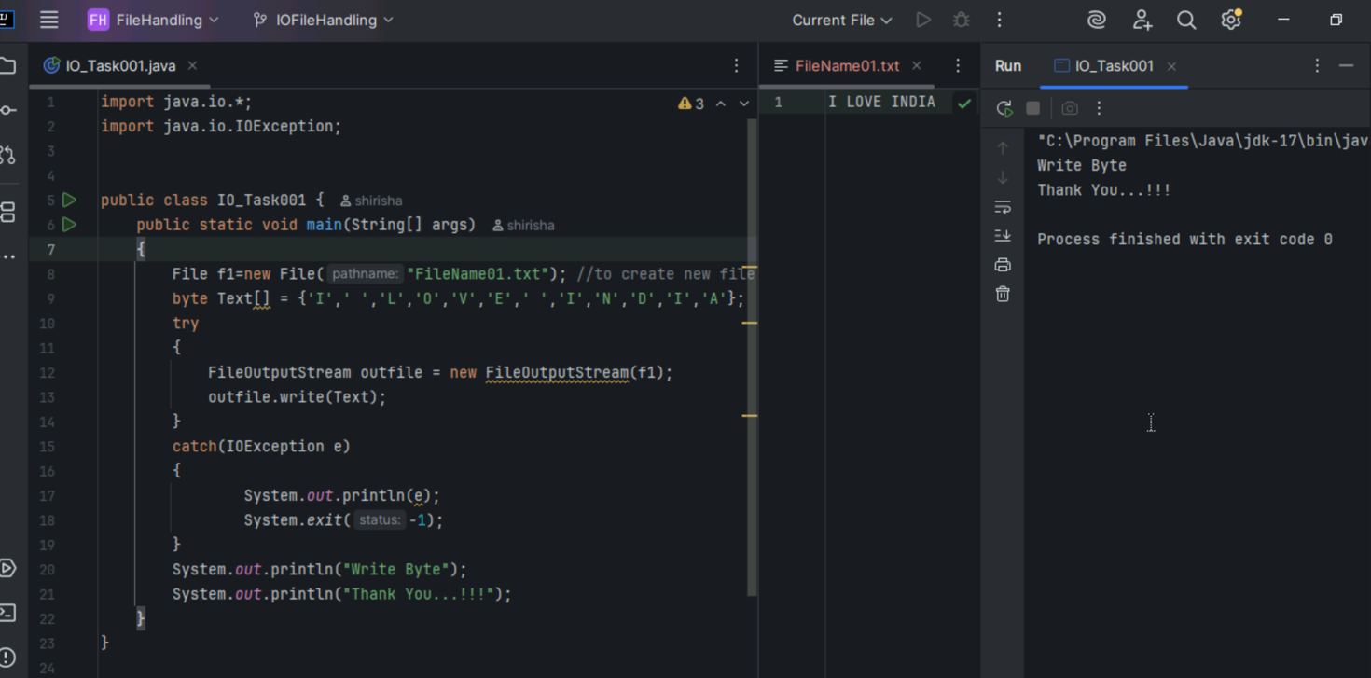

Task 2:

**Write a program which reads byte from file.**

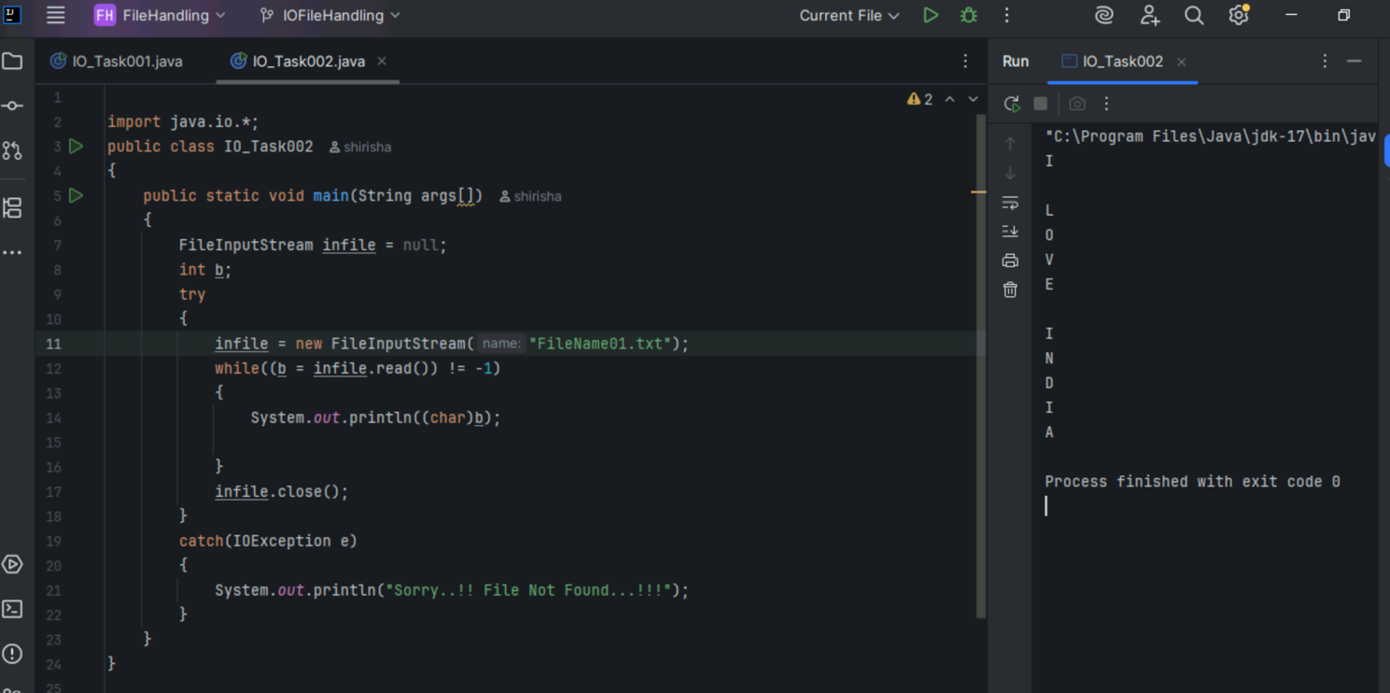

Task 3:

Taking input from the user and writing on the file…Create  a file and see the output…

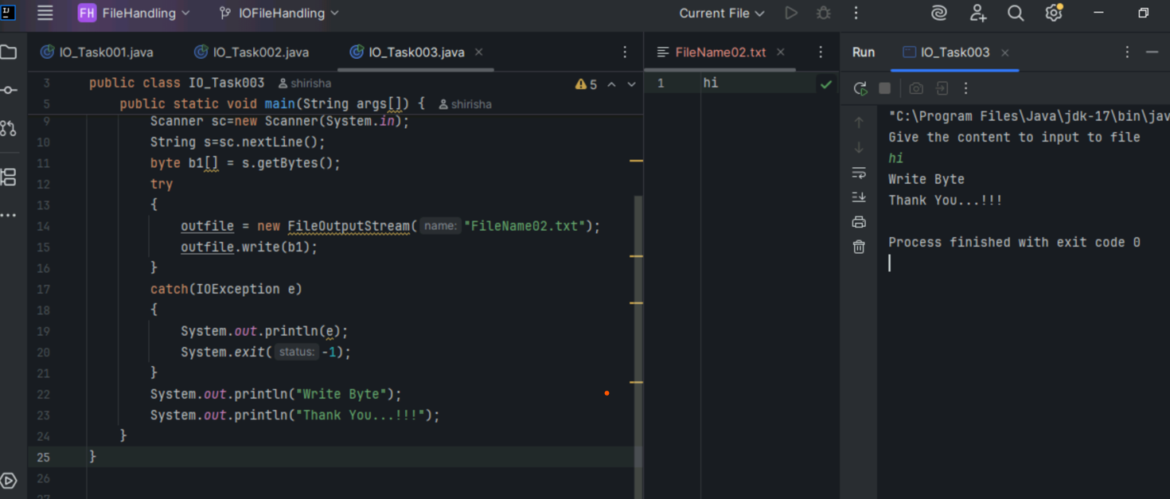

**FileReader and FileWriter**

Task 4:

Write a program which creates file and writes character into that file.

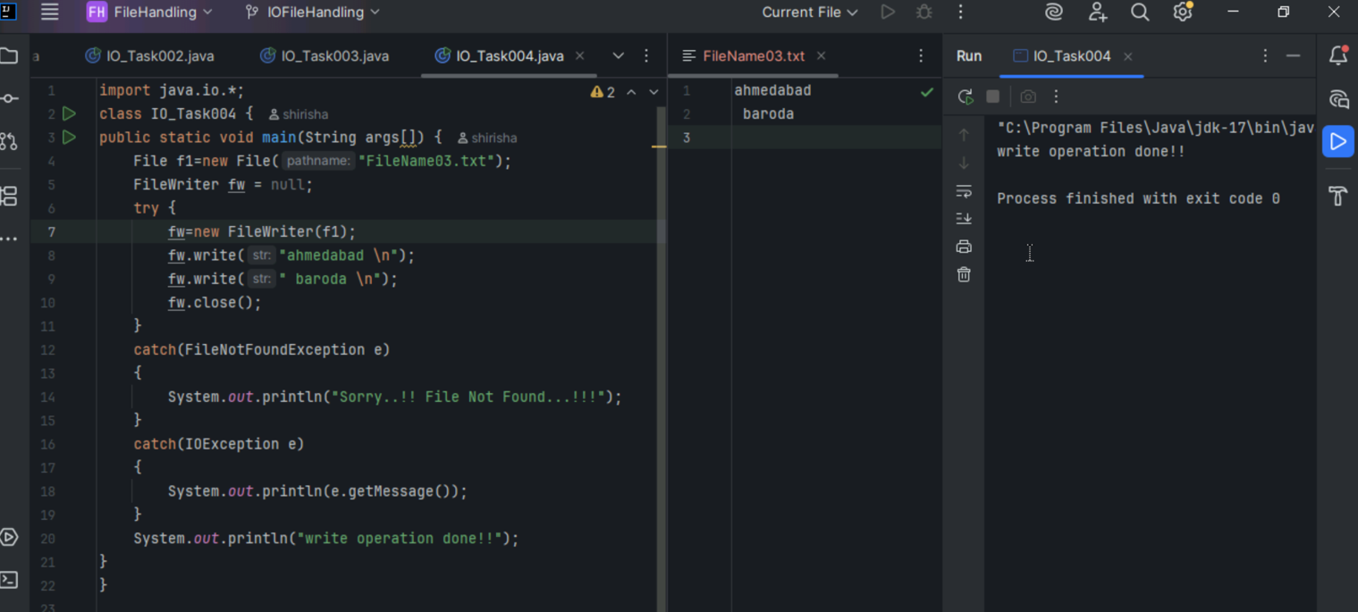

Task 5:

Write a program which reads character from file.

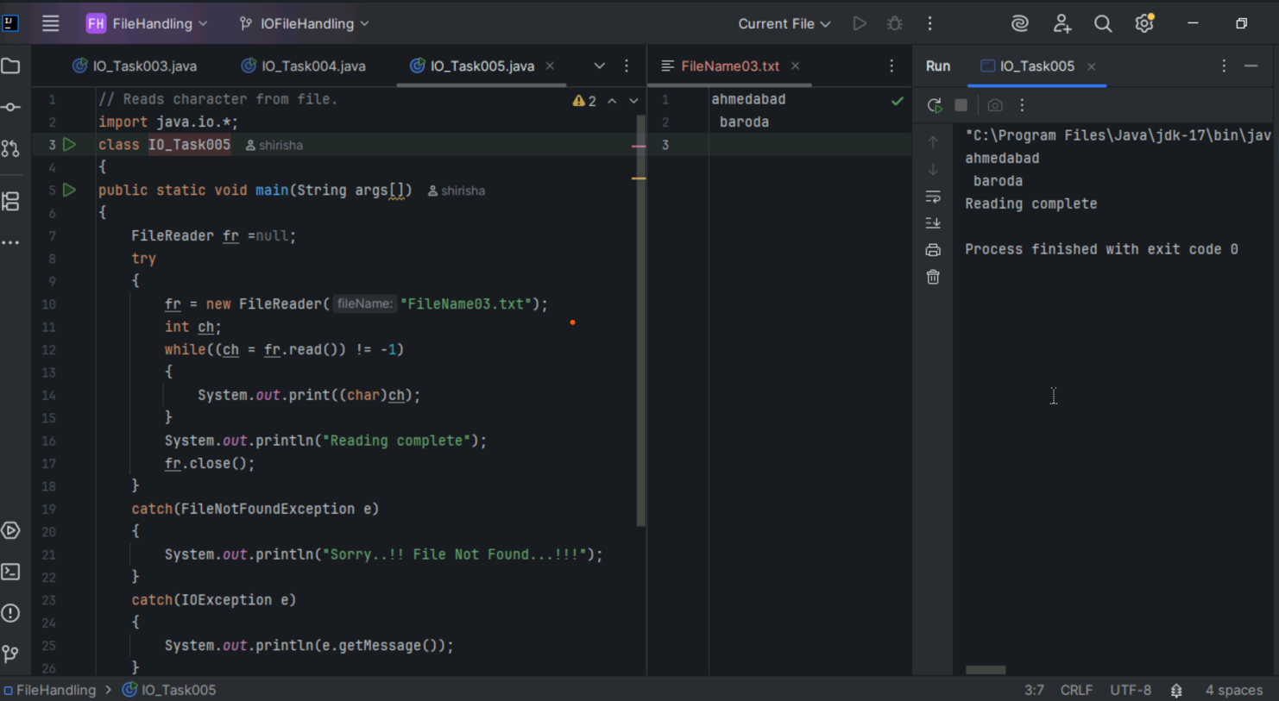

Task 6:

Write a program to read one byte at a time from a file and copy it into another file immediately

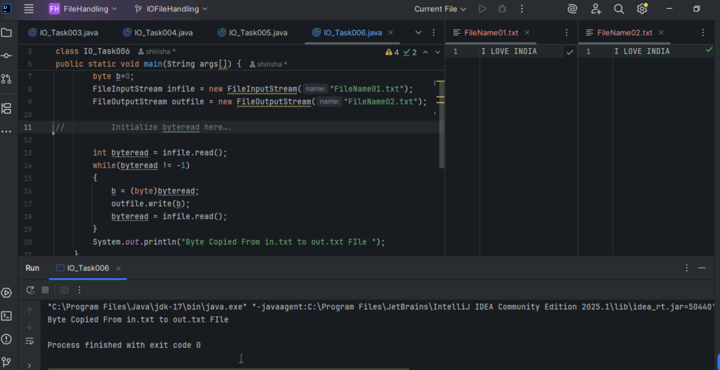

Task 7

Write a program to merge two files and print on console its content.

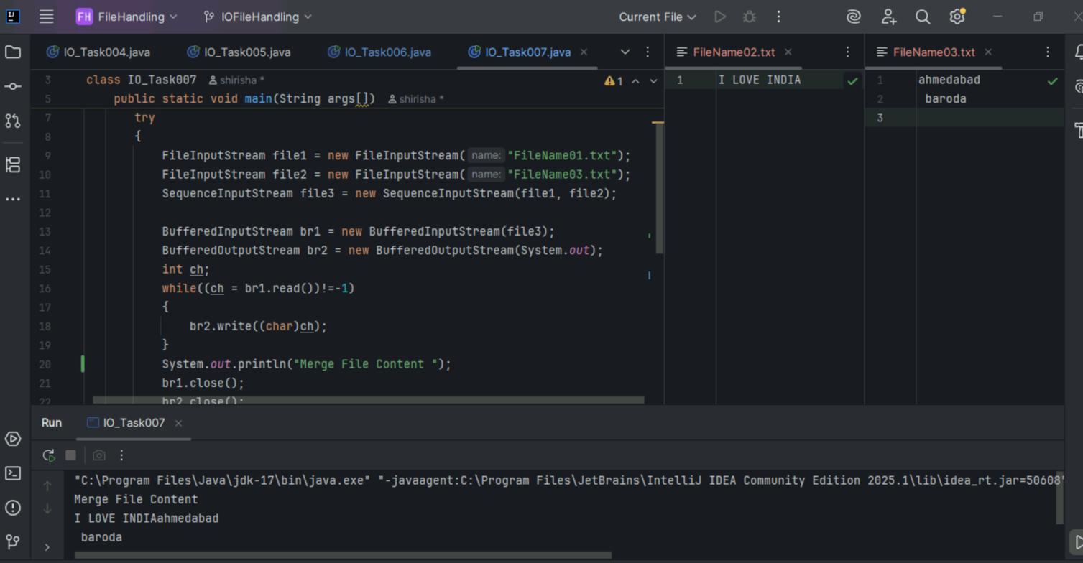

Task 8

Wap to rename a file using renameTo()

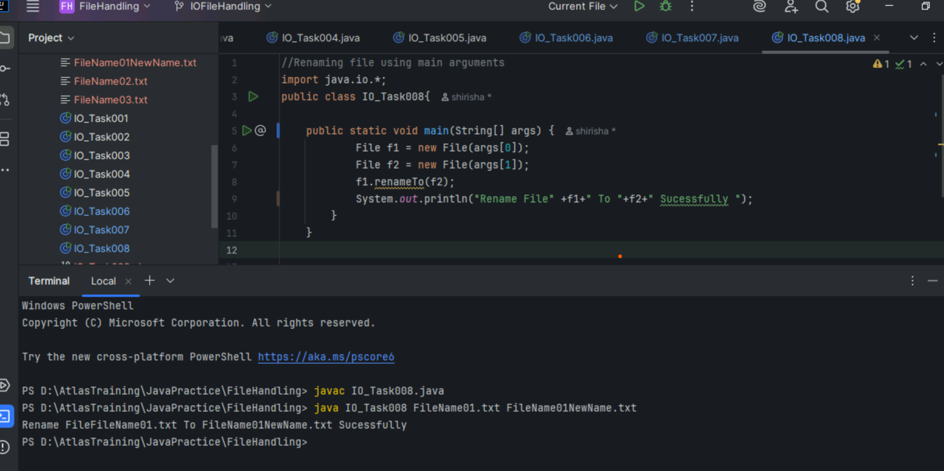

Task 9

Lambda Expression

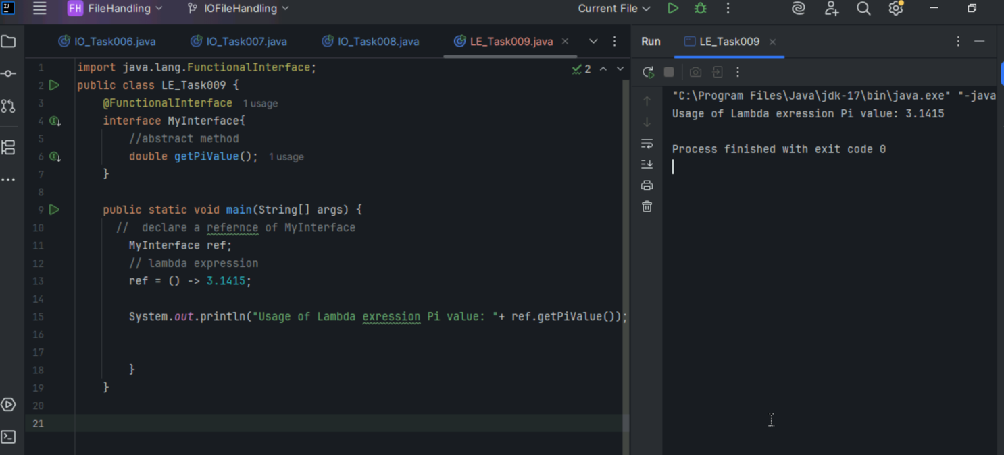

Task10

Reverse string

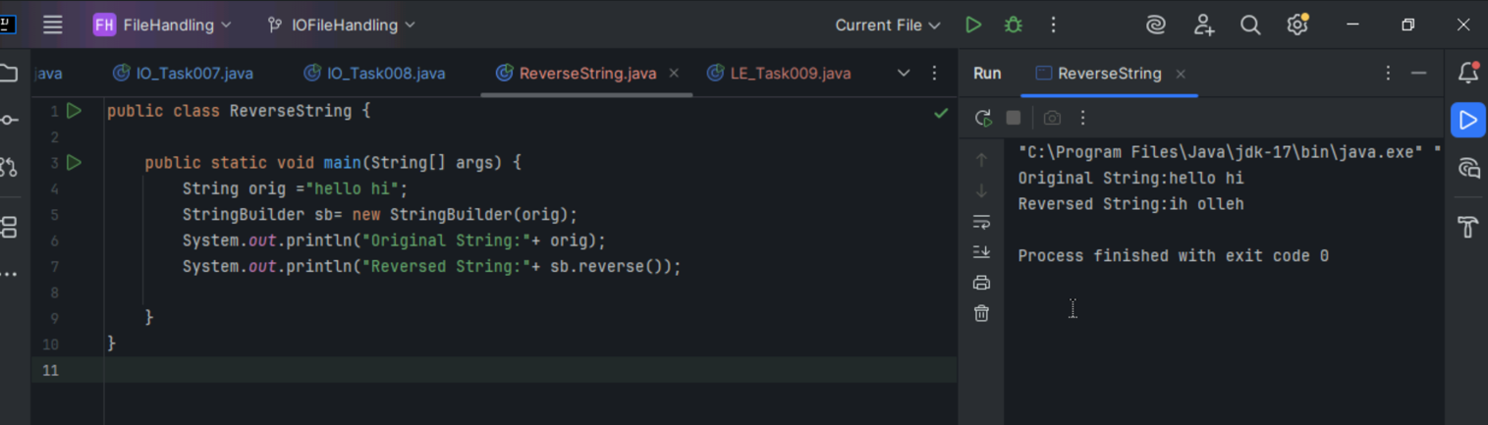

Task 11 Reverse String using Lambda Expression

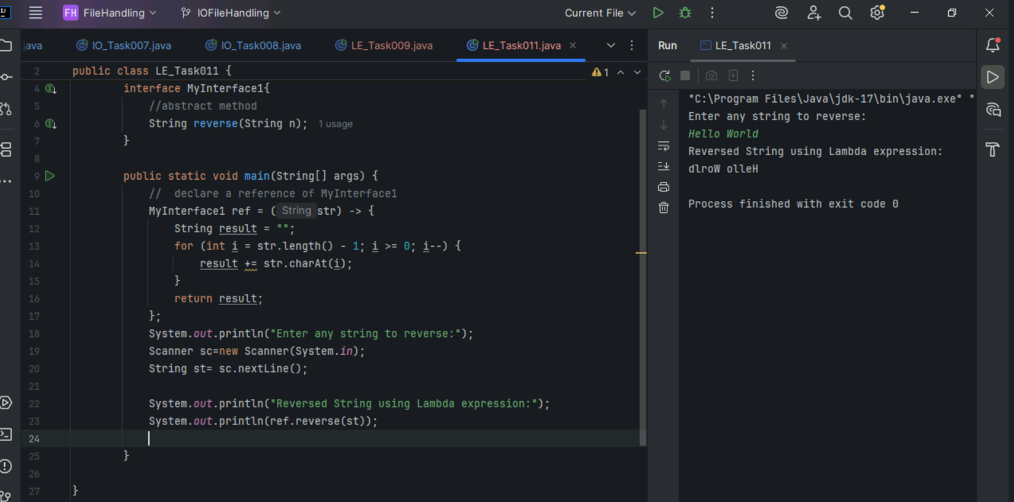

Task 12:

Wap to create an Arraylist with 5 friends names.

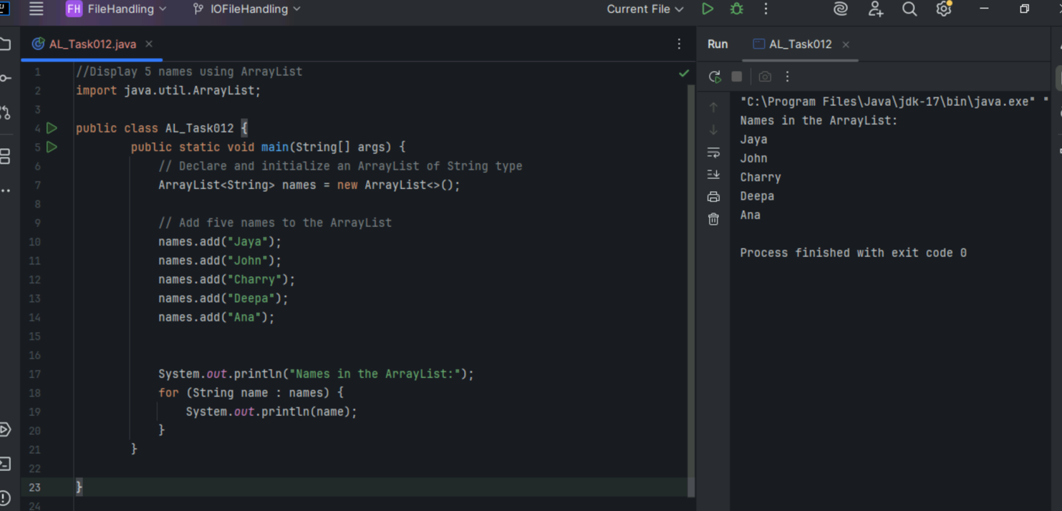

Task 13:

Wap to create a List of 5 friends names (first name and last name)

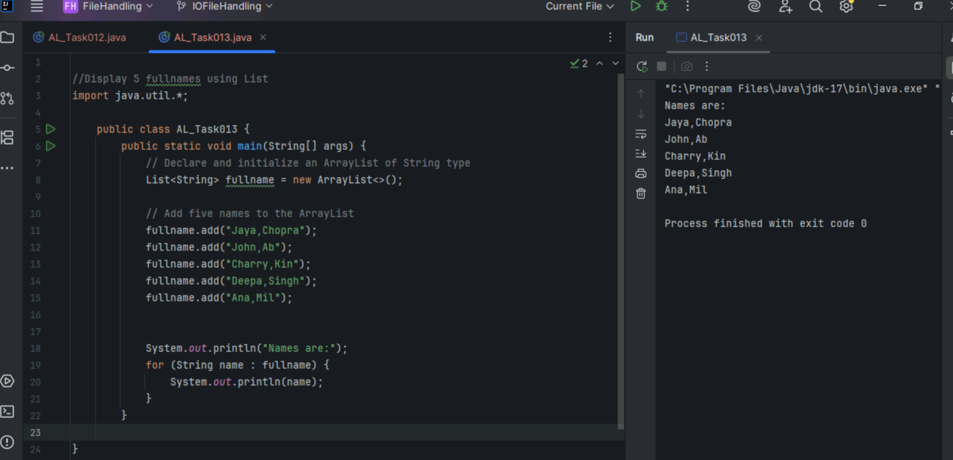

Task 14

Do Task 13 using streams and print names of friends starting with “J”, use uppercase, sort it and print it.

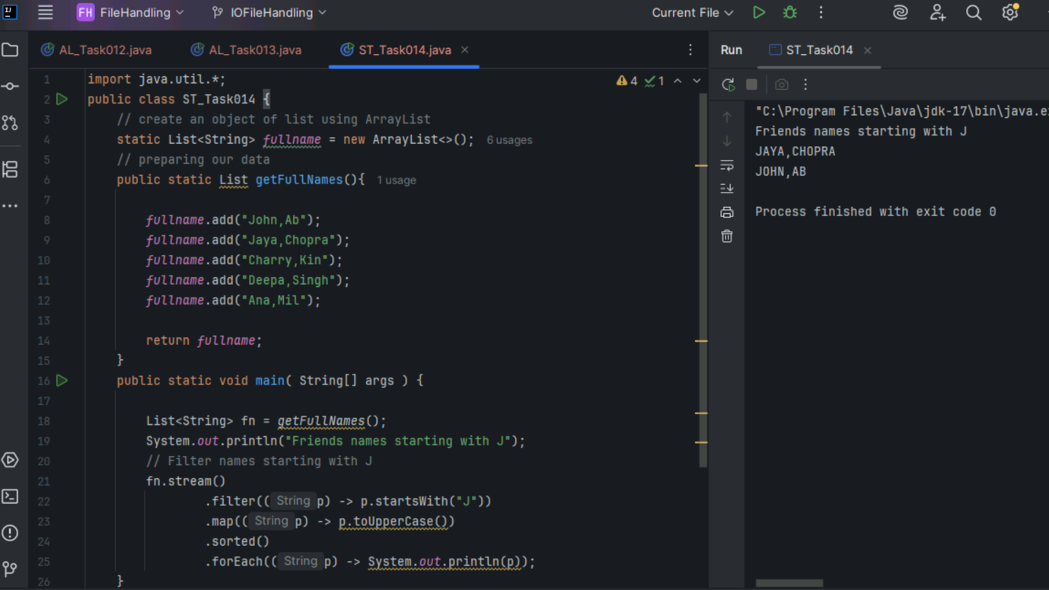

Task 15:

Collect : Terminal operator..

Wap to accept or create a list of 5 integers and display the squares of each ..

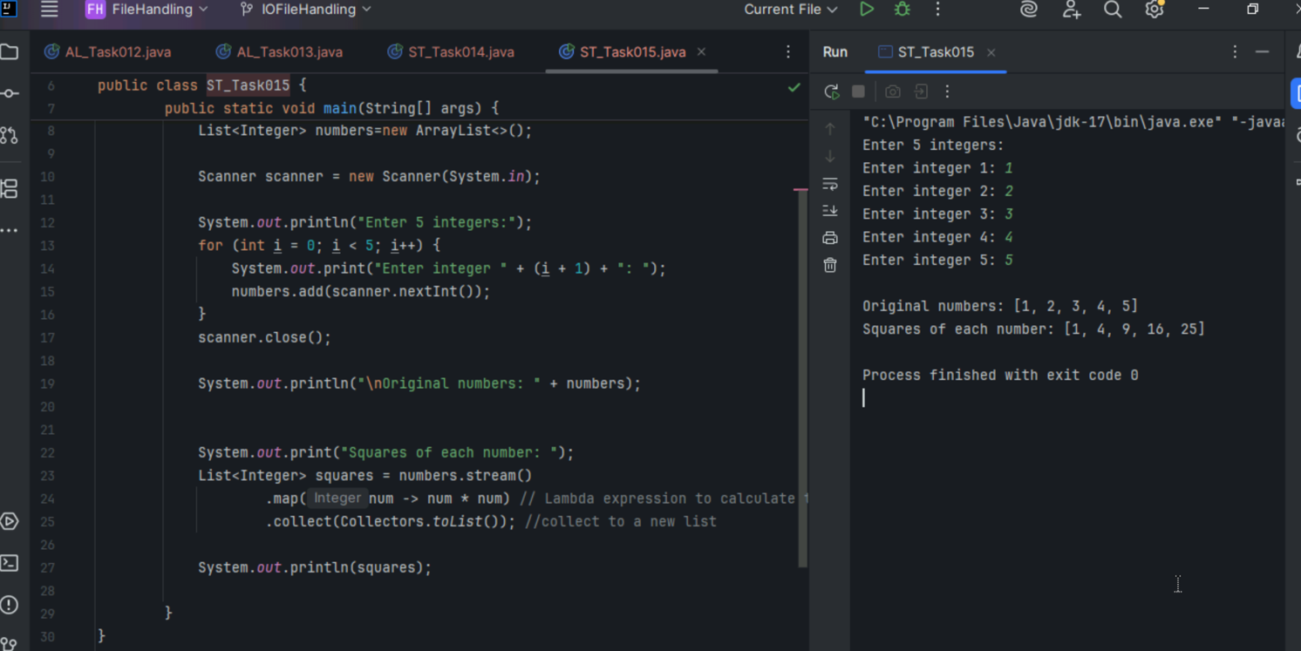

Task 16

Write a code to create an array list and filter the values which are odd numbers and display them

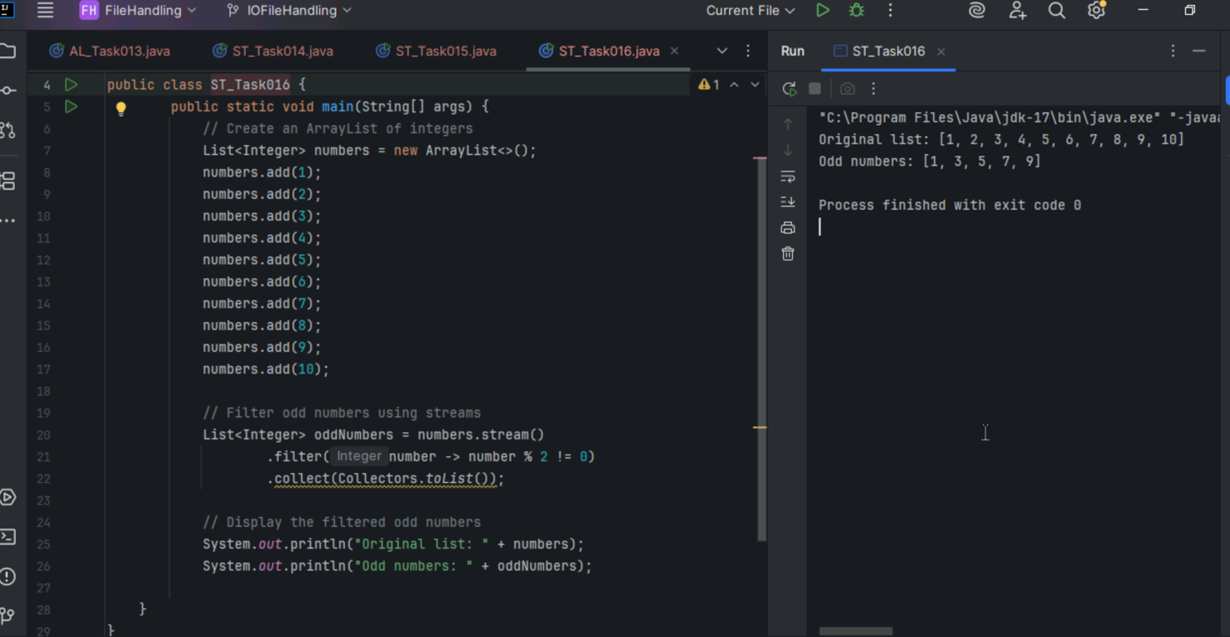

Task17

Wap to create an array list to remove duplicate values from the List.

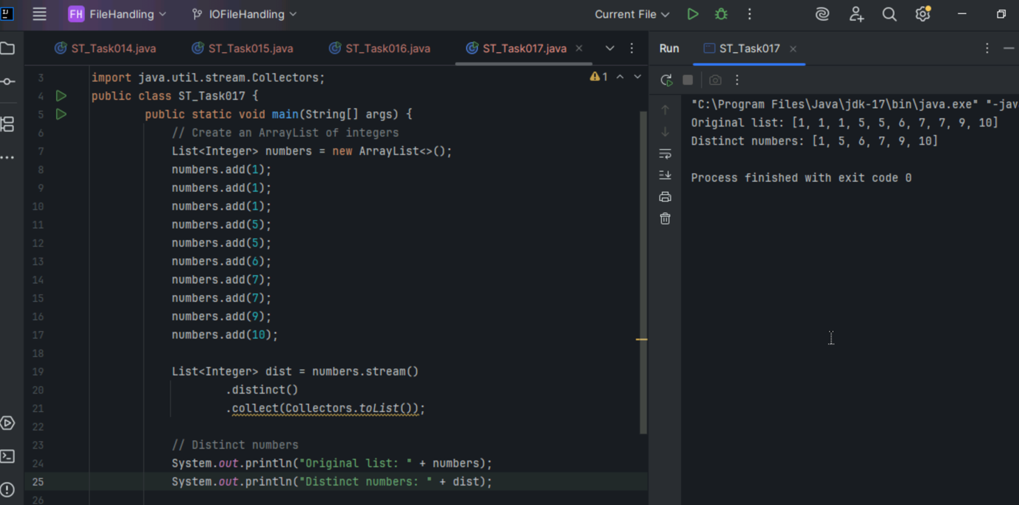

Task18

Wap to run a loop / iterate()  and limit it to 20 values (1 to 2)

While displaying use for each to limit till 10 numbers.

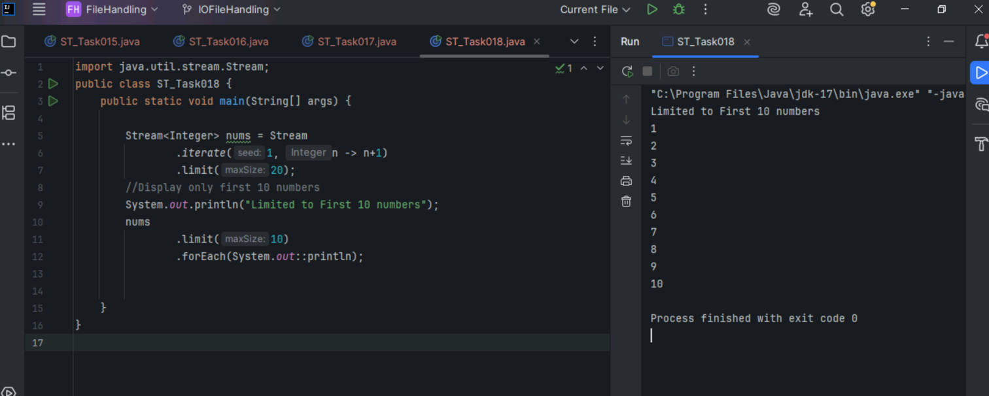

Task19

Wap to create an array List skip 15 numbers and print the output using foreach loop

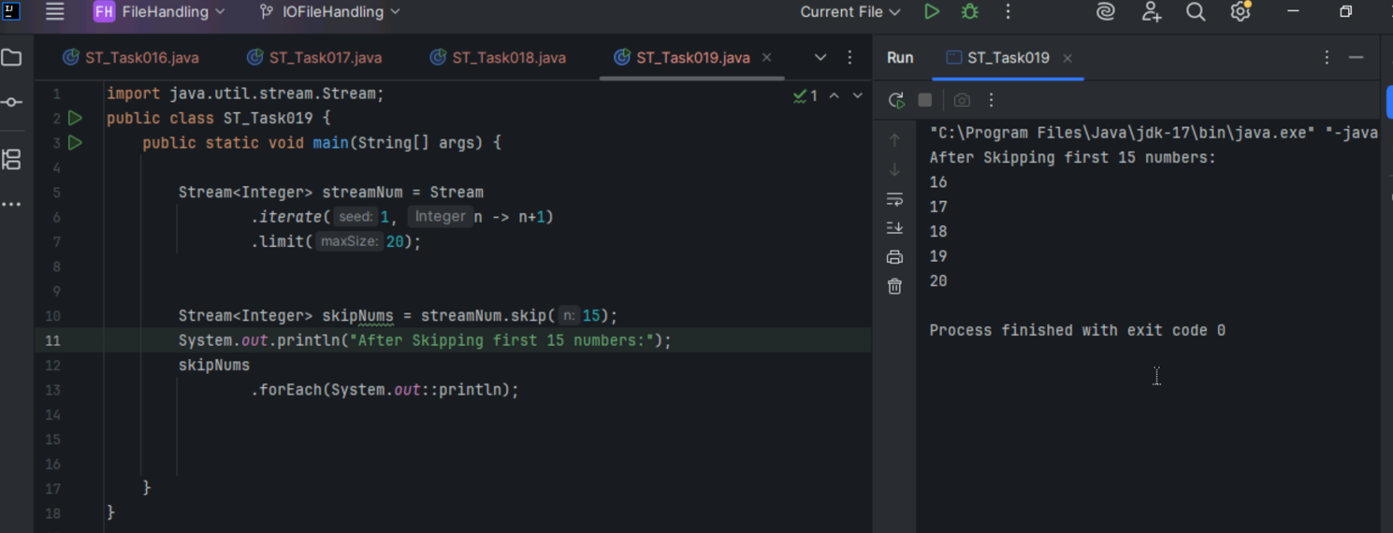

Task20

Wap to implement reduce()

